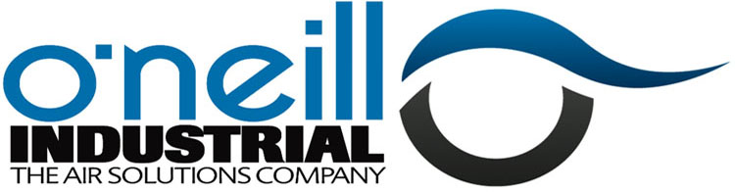

HIRE WITH CONFIDENCE

In manufacturing, compressed air is often as widely used and as vital as gas and electricity. Indeed, for pharma and food & drink manufacturers keeping production lines running around the clock with clean and reliable compressed air at high volumes is absolutely vital – so breakdowns can have serious consequences. If the air compressor can’t be fixed, speed is of the essence to help minimise the costs and setbacks connected with unscheduled repairs.
Even if an outage is planned for maintenance or the installation of new equipment, a temporary compressed air solution will keep you operational.
Seamus McGovern, Engineering Manager for Lakeland Dairies echoes this, “Increased air demand and ageing equipment had heightened the risk of production downtime in the dairy. When one of our duty compressors failed unexpectedly O’Neill Industrial provided a compressor on the same day. We couldn’t have hoped for a better response.”
Whatever the reason a company decides it needs to hire an air compressor, the decision on the right provider depends on their ability to provide a 24/7 response, have the correct equipment available, along with transport and off-loading capability.
O’Neill Industrial, with our partners Ingersoll Rand, offers a wide range of air compressors and air treatment equipment for hire to customers nationwide. For further information, please contact Austin O’Neill on 061 313888 or email austin@oni.ie

